Inventory System Development With
Trend Moment Method For Optimization
Warehouse Inventory Using Rfid Technology
( Case Study At Pt. Jansen Indonesia)
Muhammad Fathony , Good Sudirman
Program Studies System Computer
School Tall Electronics And Semarang Computers
Email: mfathony115@gmail.com

Abstract

Abstract - In warehouse department or warehouse in the company including PT. Jansen Indonesia has system service still available Not yet maximizing development technology moment this is the medium one develop fast . Including in system inventory Frequent warehouse​ happen No make it available stock And Excessive stock .​ This matter cause function inventory on warehouse No Work in a way maximum. From problem said , PT. Jansen Indonesia requires exists optimization stock with use Trent Moment Method with web- based and use RFID technology . System This covers control supply on warehouse For purchase so that reduce stock excessive nor less so supplies stock controlled , as well as a data input process that utilizes RFID so that speed up time in the data input process. On system This use Language PHP and MYSQL programming as databases as well utilizing the PHP Framework , namely Codeigniter in creation of this website . With exists system web based , makes it easy employee in data processing with appropriate time .

Keywords: Inventory , PHP, RFID, Trend Moment Method .

INTRODUCTION
Technology today has developed a lot in society. As time goes by, there has been a lot of research carried out by researchers on every problem in existing technology. The use of technology by humans began with simple tools made by humans. Several years ago, for example, the application of identification technology such as barcodes which were used in retail and warehousing. Barcodes are now considered by ordinary people. However, in the past few years this technology has been the most innovative technology in identifying goods. Today's technology is still developing rapidly and creating the latest innovations and works. One of them is Radio Frequency Identification (RFID) technology. RFID is the latest identification technology which has many advantages in identifying goods and inputting goods data which can be applied to retail, warehouses, and so on.
In the warehouse department in several companies, including PT. Jansen Indonesia has a service system that has not yet maximized current technological developments which are developing rapidly. This includes warehouse inventory where there is often no stock and excessive stock. This causes the inventory function in the warehouse to not work optimally. This problem can have a big impact on the production process being hampered because there are components that are lacking in warehouse stock, in addition to increasing expenditure costs due to irregularity in ordering excessive components. In other problems, when goods arrive in large quantities, it makes it difficult to identify the number of goods, which takes quite a long time.
In November 2017, in the warehouse department at PT. Jansen Indonesia, there are several problems that cause production to be hampered, namely the unavailability of component stock in the warehouse. In this case production cannot run because there are products that must use these components. And there are several components that are excessive in quantity, this causes the space to not be able to accommodate the large number of components in the warehouse, besides resulting in a greater risk of goods expiring because there are too many components. In another aspect, the irregular number of component ordering costs creates quite large losses for the company.
PT. Jansen Indonesia is a company that has been operating in the furniture and home furnishings sector since 1981. This industry processes components into various shapes or models until they become finished products (Finished Good Products) that are ready for export. The company is characterized by the production of furniture and decoration derived from antiques and inspired by classic styles. This company's products, such as tables, cupboards, sofas and so on, use various inspiring carvings that combine all cultures and backgrounds from each region. PT. Jansen Indonesia has developed into an international company with wholly owned factories in Asia and sales presence in Europe, Canada, the United States and Hong Kong.
In To control warehousing to function optimally, it is necessary to carry out analysis. There are several methods that can be used, such as the Semi Average Method, Trend Moment Method, and Least Square Method . In this research, the analysis method used is the Trend Moment Method . The Trend Moment method is considered to have advantages compared to other methods, namely the use of parameter X or historical data. This is because the values in parameter
By utilizing technology that is currently developing, such as websites as technology or media that can control a system properly, such as sending, receiving and reporting with access that saves more time. From these problems, PT. Jansen Indonesia requires optimization of warehouse inventory using the web-based Trend Moment Method and using RFID technology. This system includes stock control in the warehouse for purchasing components so that stock inventory is controlled, as well as a data identification process that utilizes RFID to shorten the time in the data input process. With a web-based system, it makes it easier for employees to process data in a timely manner .
RESEARCH METHODS
- RnD (Research and Development)
In this research the author used the Research and Development development procedure , namely the research method used to produce products and test the effectiveness of these products. Research and development Research and Development is a research method used to produce analytical products and test the effectiveness of these products (Borg and Gall, 1983).

Figure 1. Development Model
Research and Development ) development method procedure , these 10 steps must be implemented correctly before producing a new product that will be created. Of the ten research and development steps, only steps one to six are needed to fulfill the requirements for a strata-1 thesis, namely:

- Potential Problems
At this research stage, there was a problem that emerged at PT. Jansen Indonesia. PT. Jansen Indonesia is an international company that has many markets including the Netherlands, England, America and others. This increases factory productivity. However, as there are more and more customers, there is often a shortage of stock in warehouse inventory.
- Gathering Information (Research and Information)
After the potential and problems have been identified, it is then necessary to collect various data and information that can be used as material for product planning to overcome these problems . As for data collection in this research, the author took the following steps:
      - Field Study (Observation)
Observations were carried out directly to research and survey the scope of the problems that will be raised in this research. Survey conducted at PT. Jansen Indonesia, is guided directly by the management, namely the PPIC section. By making these observations, the author can see directly the existing problems and get realistic data.
      - Interview (Interview)
Interviews were carried out in stages, with the director, deputy director, warehouse department and PPIC taking into account the right time and situation. This is done so that the data obtained is detailed and complete. Because the company does not have much time to answer the questions asked by the author.
      - Study of literature
Data was collected by taking it from books and journals related to the problems in this research. From collecting data from various sources, the method used to solve problems in this research is the Trend Moment Method.
The Trend Moment method is a way of predicting data, such as predicting the number of orders, sales and so on. One of them is based on historical data from one variable, namely from data on the number of orders over several historical periods. The following is an explanation of the Trend Moment Method formula:
Y = Trend value or variable to be predicted
a = Constant number
b = Trend line coefficient
X = Time index (starting from 0,1,2,…)
The basic formula used: Y = a+b(X)
Equation (i): ∑Y = na + b.∑X
Equation (ii): ∑XY = a.∑X + b.∑X
∑Y = Number of Trend Values or variables to be predicted
n = Number of data/period taken (distance from start to end period)
∑X = Number of time indices
∑XY = The sum of the results of multiplying X and Y
- Product Design (Develop Prelimnary Form Of Product)
Create product designs and develop the initial form of the product that will be produced. In this step the author carries out and designs a product where the design is still conceptual and will be realized in the form of a chart or image so that it can be used as a guide in assessing and creating a program.
- Design Validation (Preliminary Field Testing)
Carrying out initial trials on product designs, namely validating them with a team of experts. At this stage, the finished product design is submitted to a team of experts to test the feasibility of the system, whether it is feasible or not, and used as an Inventory System to determine future warehouse needs.
- Design Improvements (Main Product Revision)
In the design improvement stage, it is carried out after being validated by experts or experts who then hold discussions to discuss whether there are any deficiencies in the product. Evaluation is carried out if the product has deficiencies according to the results of validation carried out by experts or experts.
- Product Trial (Main Field Testing)
Wider field trials after validating and revising the product. By validating the user or users of this inventory system. In this research, the user in question is the Warehouse Admin. Admins are asked to use this system, to find out whether the implementation of this system can effectively help in warehouse optimization .

  - UML (Unified Modeling Language)
              - Use Cases
Figure 3. Use Case

              - Activity Diagrams
        - Warehouse Admin Manage Requests
Figure 4. Warehouse Admin Activity Diagram Manage Requests

  - Warehouse Admin Activity Diagram Manage Goods Data
Figure 5. Warehouse Admin Activity Diagram Manage Goods Data

  - Activity Diagram Warehouse Admin Manage Stock
Figure 6. Warehouse Admin Activity Diagram Manage Goods Data

  - Warehouse Admin Activity Diagram Manage Orders
Figure 7. Warehouse Admin Activity Diagram Manage Orders

RESULTS AND DISCUSSION
    - Forecasts can be calculated manually using data from one of the items, namely the bookcase , obtained from research results. The following is a manual calculation:

Table 1. Research Data
Year | Expenditure (Y) | Time (X) | X*Y | X ²
January 2016 | 120 | 0 | 0 | 0
February 2016 | 140 | 1 | 140 | 1
March 2016 | 259 | 2 | 518 | 4
April 2016 | 270 | 3 | 810 | 9
May 2016 | 200 | 4 | 800 | 16
June 2016 | 211 | 5 | 1055 | 25
July 2016 | 100 | 6 | 600 | 36
August 2016 | 257 | 7 | 1799 | 49
September 2016 | 212 | 8 | 1696 | 64
October 2016 | 129 | 9 | 1161 | 81
November 2016 | 115 | 10 | 1150 | 100
December 2016 | 100 | 11 | 1100 | 121
January 2017 | 70 | 12 | 840 | 144
February 2017 | 94 | 13 | 1222 | 169
March 2017 | 180 | 14 | 2520 | 196
April 2017 | 230 | 15 | 3450 | 225
May 2017 | 270 | 16 | 4320 | 256
June 2017 | 300 | 17 | 5100 | 289
July 2017 | 332 | 18 | 5976 | 324
August 2017 | 259 | 19 | 4921 | 361
September 2017 | 270 | 20 | 5400 | 400
October 2017 | 200 | 21 | 4200 | 441
November 2017 | 211 | 22 | 4642 | 484
December 2017 | 100 | 23 | 2300 | 529
January 2018 | 257 | 24 | 6168 | 576
February 2018 | 266 | 25 | 6650 | 625
March 2018 | 235 | 26 | 6110 | 676
April 2018 | 334 | 27 | 9018 | 729
May 2018 | 332 | 28 | 9296 | 784
June 2018 | 260 | 29 | 7540 | 841
July 2018 | 280 | 30 | 8400 | 900
August 2018 | 270 | 31 | 8370 | 961
September 2018 | 300 | 32 | 9600 | 1024
 | ∑Y | ∑X | ∑XY | ∑X2
AMOUNT | 7163 | 528 | 126872 | 11440
AVERAGE | 217.06

- Find the values of a and b
The first step is to look for the values of a and b to determine the trend moment pattern.
∑Y = an + bX
∑XY = aX + bX ²
7163 = 33a + 528b
126872 = 528a + 11440b
b = ((33 x 126872) - (7163 x 528) / (33 x 11440) - (528 x 528))
b = (4186776 – 3782064) / (377520 – 278784)
b = 404712 / 98736
b = 4,098

a = ((7163 x 11440) - (528 x 126872) / (33 x 11440) - (528 x 528)
a = (81944720 – 66988416) / (377520-278784)
a = 14956304 / 98736
a = 151.477
- Calculating the forecast for October 2018
The next step is to look for Y, which is the result of forecasting for October which has not been influenced by the seasonal index.
Y = a + bX
Y = 151,477 + (4,098 x 33)
Y = 151.477 + 135.264
Y = 286,741
With the results of the equation above, it is predicted that the need for goods for October 2018 will be 286.7

    - Counting forecasting booking automatically use the application.
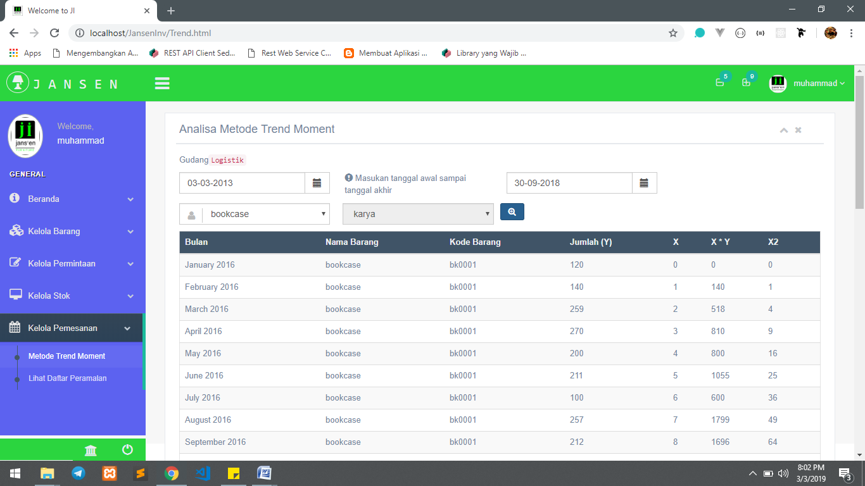
Figure 8. Forecasting for October Using Applications
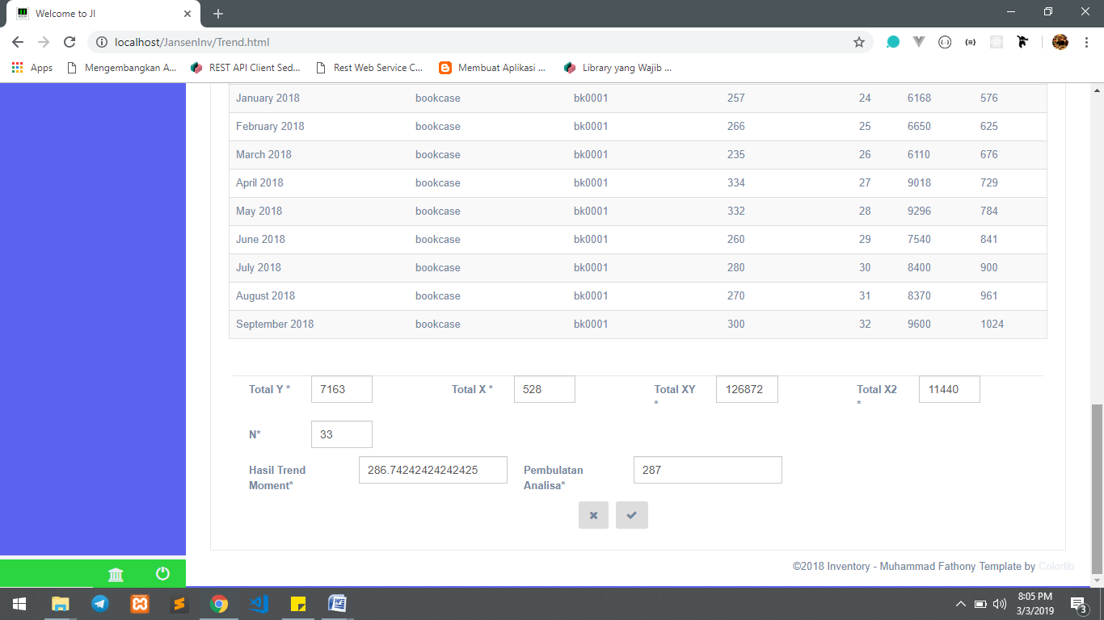
Figure 9. Forecasting Results for October
The forecast for orders for items called bookcases is October 2018, namely 287 pcs. The actual usage in October 2018 was 306, so there is a difference of 19 pcs.
    - The Inventory System provides information about insufficient stock and stock that is below the minimum stock
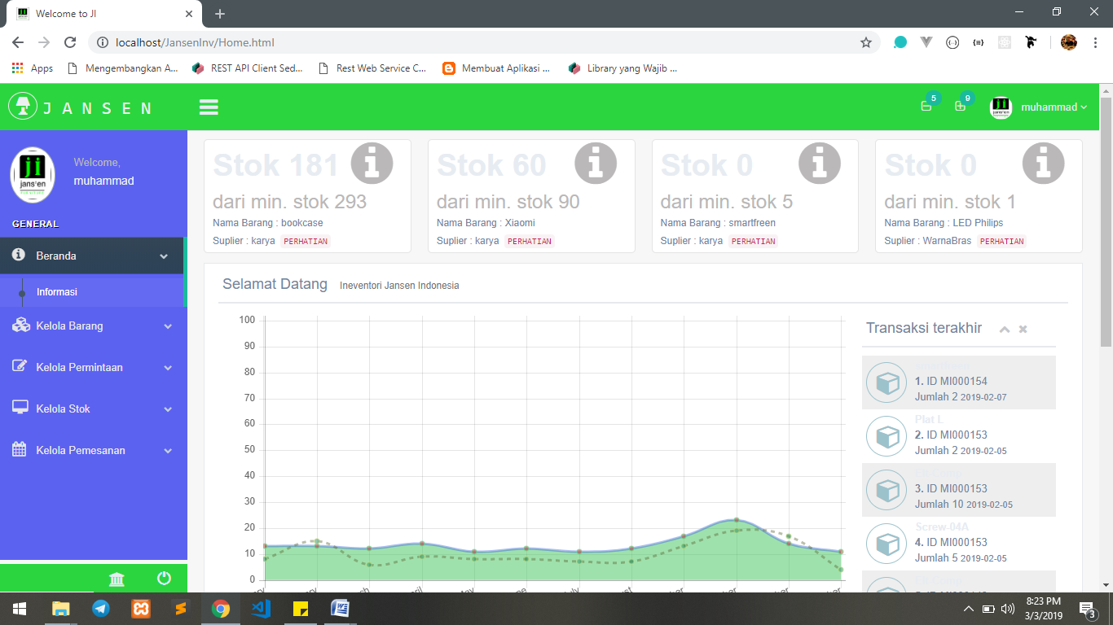
Figure 10. Display of out-of-stock information
The Inventory System provides information about stock that is out of stock or below the minimum stock which will then be followed up by the admin to bring in goods based on goods and forecasting results using the Trend Moment Method.
    - RFID identifies goods on system inventory
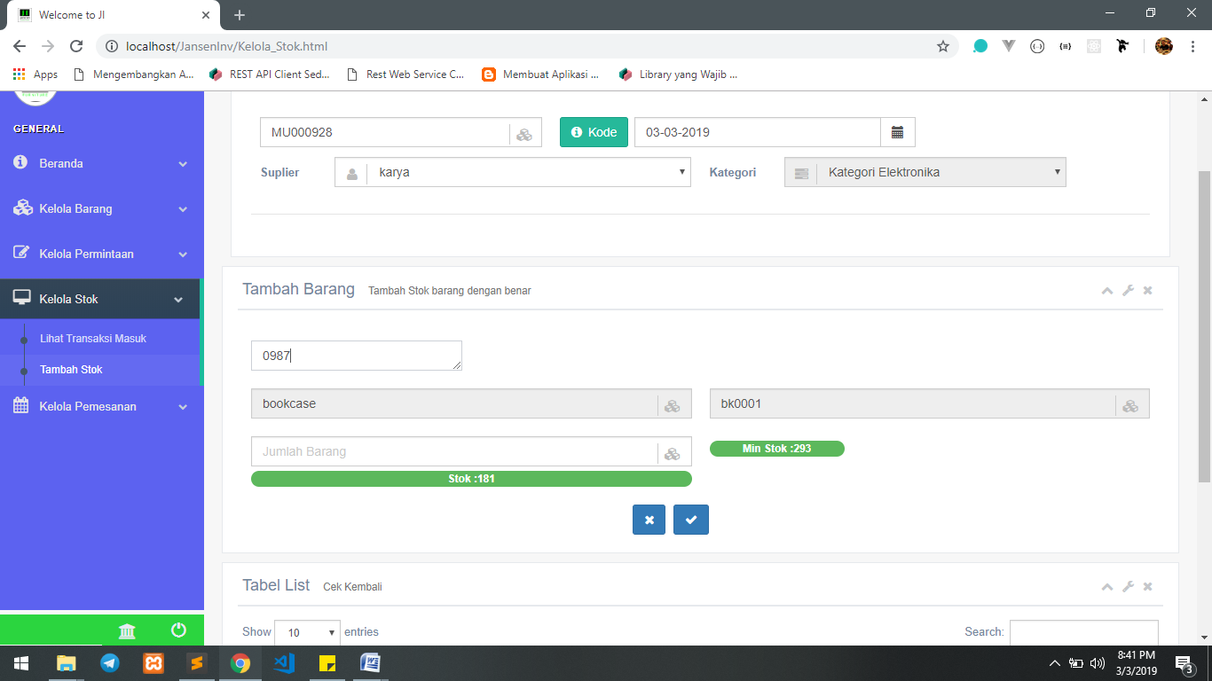
Figure 11. Identification of goods using RFID
CONCLUSIONS AND SUGGESTIONS
  - Conclusion
Based on the analysis and results of this system design, it can be concluded as follows:
- Based on the results of manual forecasting and automatic forecasting using the application, the same results were obtained, namely 287 pcs for ordering bookcase goods in October 2018 and actual usage in October 2018, namely 306 . Inventory System Application Using the Trend Moment Method can manage component orders for warehouse inventory.
- In testing the Inventory System Using the Trend Moment Method to Optimize Goods Inventory Using RFID Technology to identify goods, it has provided results that are in accordance with item information such as stock, supplier names and others which can be seen in Figure 11 . This inventory system utilizes RFID to automate item identification and can provide stock information on items that are out of stock or approaching minimum stock.
  - Suggestion
Considering the various limitations experienced by the author, from the conclusions above and the system that has been created, several suggestions can be put forward for consideration for further development, namely as follows:
- The Trend Moment Method can be used if you have data that is trend analysis or long-term with a minimum of 12 months or 1 year of data. So applications can be developed using other methods without having to have long-term data history.
- Inventory System Using the Trend Moment Method for Optimizing Warehouse Inventory Using RFID Technology to read items with RFID one by one. It is necessary to develop tools for RFID readers that can read items simultaneously in one place.
BIBLIOGRAPHY
Adisaputro, Gunawan, Anggraini and Yunita, 2007 ; "Business Budget: Analysis, Planning and Profit Control" , Yogyakarta: STIM YKPN,.
Agus Purnama, 2012: "Understanding and components of Radio Frequency Identification" , http://elektronika-dasar.web.id/pengertian-dan-kompon-radio-frequency-identification-rfid/ (Accessed 11 June 2018),.
André, 2017 ; "Learning HTML and Understanding HTML" , https://www.duniailkom.com/belajar-html-pengertian-html/ (Accessed 23 February 2018),.
Ase Satria, 2016 ; "Inventory Theory (Understanding, Objectives, Functions, Types and Costs of Inventory According to Experts)" , www.materibelajar.id/ 2016/04/theorie-supply-pengertian-besar.html (Accessed 25 February 2018),.
Bunafit Nugroho, 2014 ; "Basics of PHP - MySQL Web Programming with Dreamweaver" , Yogyakarta: Gava Media,.
Denny Trisna, 2012; “Inventory (Inventory)” , http://www.rantaipasok .com/201 2/12/persediaan-inventory.html (Accessed 10 March 2018),.
Difana Meilani, Indah Albani Putri, 2015 ; "Designing a Barcode Automation System by Evaluating Performance in Warehouse Transaction Activities" , Padang: Department of Industrial Engineering, Andalas University, Padang.
Dr. Kusrini, M. Kom, Dias Ayu Budi Utami, 2016; "Design and Construction of a Sales Forecasting System for Controlling Rice Inventory Using the Trend Moment Method" , Yogyakarta: STIMIK AMIKOM,.
Fiati, Rina, 2010 ; "Application of a Goods Sales Forecasting Decision Support System" , Journal of Science and Technology. Vol. 3, no. 2, pp. 1-16,.
Gaspersz , Vincent, 2005; "Production Planning and Inventory Control Based on the Integrated System Approach of MRP II and JIT towards Manufacturing 21" , Jakarta: PT. Gramedia Pustaka Utama,.
Kadir, Abdul, 2014 ; "Introduction to Information Systems Revised Edition", Yogyakarta: Andi Offset,.
Kusuma, H. 2004; "Production Planning & Control", Yogyakarta : Andi,.
Muchlisin Riadi, 2016; "Understanding, Objectives and Benefits of Warehouses" , https://www.kajianpustaka.com/2016/04/pengertian-besar-dan-besar-gudang.html (Accessed 25 February 2018),.
Muhammad Fuad, Dina Novita, 2016 ; "Preparing the Ceramic Tiles Sales Budget at the Aira Mandiri Group Shop in Langsa City using the Trend Moment Method," Langsa: Lecturer and Alumni of Samudra University, Meurandeh Campus,.
Prof. Dr. Jogiyanto HM, MBA., Akt, 2009 : "Information Technology Systems", Yogyakarta: Andi Offset,.
Paul Andersson, 2005 ; "Information Security: Radio Frequency Identification Technology in the Federal Government" , United States Government Accountability Office. http://www.gao.gav/new/items/ d05551.pdf (Accessed 23 February 2018),.
Restu Buana Kusuma Sakti Nugraha, 2011 ; "Designing a Warehouse Information System Prototype Using Radio Frequency Identification (RFID) Technology" , Surakarta: Faculty of Engineering, Sebelas Maret University,.
Siagian, Dergibson and Sugiarto, 2006 ; "Statistical Methods for Business and Economics" , Jakarta: PT. Gramedia Pustaka Utama,.
Sora N, 2014: "Knowing the meaning of a website and its types" , http://www.pengertianku.net/2014/09/mengetahui-pengertian-website-dan- Jenisnya.html (Accessed on 23 February 2018),.
Sukamto, R. A, and Shalahudin, M. 2014 ; "Structured and Object-Oriented Software Engineering" . Bandung: Informatics Bandung.
Sugiyono, 2015: "Quantitative, Qualitative and R&D Research Methods" , Bandung: Alfabeta,.
Taufik Mulya Ibrahim, 2012 ; "Design and Development of Radio Frequency Identification (RFID) Technology for Optimizing Warehouse Management Systems (WMS)" , Semarang: Faculty of Engineering, Dian Nuswantoro University,.

