Design and Development of an Automatic Lock System for Cupboards Using Fingerprint Based Microcontrollers

Afni Mardhiyah , Siswanto
Department of Computer Systems, STEKOM Semarang
Email: afni14@gmail.com

Abstract: Seeing the current condition of the community, most of them still use simple security, such as the cupboard security system at Weleri Muhammadiyah 3 Vocational School, the situation is that schools still use one key in one cabinet where only one person is employed while more than one TU officer is if other officers will use the cupboard, they must look for or wait for the key holder first and the method is not effective for emergency matters. The importance of making security in the closet is because the school is the school with the highest number of students and requires safe storage media for diplomas (not yet taken). Therefore, it is necessary to make a cabinet lock application system using microcontroller-based fingerprints. This cabinet lock system uses a fingerprint scanner as the main determinant of whether the cabinet can be opened automatically. From research at Weleri Muhammadiyah 3 Vocational School, this system was able to add a security system to the cabinet to control access rights in the cabinets that were considered important.
Keywords: Microcontroller, Arduino Uno, Automatic Lock, Security System.

- PENDAHULUAN
Currently, various kinds of systems have been developed using modern technologies, one of which is fingerprint scanner technology . A fingerprint scanner is one of the most commonly used biometric technologies , namely by capturing images of human fingerprints. A fingerprint scanning system has two jobs, namely taking a fingerprint image, and deciding whether the fingerprint flow pattern from the captured image is the same as the fingerprint flow pattern in the database . There are several ways to take a picture of someone's fingerprints, but one of the most widely used methods today is optical scanning . The heart of an optical scanner is a charge coupled device (CCD), the same light sensor system used in digital cameras and camcorders . A CCD is a simple array of light-sensitive diodes called photosites , which produce electrical signals that respond to photons of light (Oroh, 2014) . Each photosite records a pixel, a small dot that represents light and hits it. These pixels form a pattern of light and dark from a scanned image of a person's fingerprint.
The need for an access control system is the most important thing in everyday life, considering the current condition of society, most of them still use simple security measures, such as the cupboard security system at Muhammadiyah 3 Weleri Vocational School, looking at the current situation, schools still use one key for one cupboard, where there is only one key holder while there is more than one TU officer, then if another officer wants to use the cupboard they have to look for or wait for the key holder first and this method is less effective for emergency matters . It is important to create a fingerprint automatic lock system which aims to simplify access rights for users who do not need to rely on just one key.
Therefore, it is necessary to create a cabinet lock application system using microcontroller- based fingerprints that uses as few devices as possible so that the system size specifications can be applied to real objects . The assembled system consists of a fingerprint scanner , LCD , and Arduino Uno . This cupboard lock system uses a fingerprint scanner as the main determinant of whether the cupboard can be opened automatically. This fingerprint scanner will be controlled by a microcontroller. The microcontroller is the main brain/controller which receives input in the form of fingerprint recognition to control the cupboard lock. The LCD display will display reports in the form of commands to the cabinet user.
It is hoped that the design of this application system will increase the practicality of using cupboard locks. Based on the background presented above, the title " Design of an Automatic Lock System for Cabinets Using Microcontroller- Based Fingerprints " was chosen .
  - Identification Problem
Based on setting behind above , obtained a number of problem among them is :
- Currently cupboards still use one key on one cupboard .
- User cupboard more than one person, whereas cupboard must still locked For guard security .
- Manual keys cannot be attached to the user, so the key may be lost or forgotten.
  - Formulation of the problem
Problem formulation is carried out to facilitate the research process so that it does not deviate from the problem being studied. Based on the background that has been mentioned , the author will formulate the problem faced, namely:
- How to apply a fingerprint scanner as a security system in cupboards as a replacement for the current key, which can be accessed by all TU officers without relying on one object (the key) but remains safe.
- How impact positive And negative usage system key automatic fingerprint fingers that will applied on cupboard ?
  - Restricting the problem
The scope of this research is as follows:
- This system only focuses on key design.
- Does not include information when a cupboard door is forced to open .
- This system is designed using a fingerprint scanner and an Arduino Uno microcontroller .
  - Research purposes
objectives of this decision support system include:
- Applying a fingerprint scanner to the cupboard using an Arduino Uno thus increasing security in the cupboard for storing diplomas and equipment at school.
- Research and determine the impact of using the system key automatic fingerprints on the cupboard at SMK Muhammadiyah 3 Weleri.
  - Benefit Study
research benefits of this decision support system include:
            - Theoretical Benefits
                - Contribute ideas for the development of systems related to microcontrollers.
                - As a basis and reference for further research related to improving the development of microcontroller systems and as material for further study.
            - Practical Benefits
- For Researchers
To find out to what extent the author can design an automatic lock system for cupboards using a microcontroller based fingerprint scanner .
- For Academic
Becomes reference material for students to create a system that also uses a fingerprint scanner and Arduino Uno microcontroller .
- For Research Place
Makes it easier system right access cupboard at Muhammadiyah Vocational School 3 Weleri to get used all employee without depend on One key .

- THEORETICAL BASIS
- Design
Design Get up is depiction , planning , and making sketch or arrangement from a number of separate elements​ into the something complete unity​ And works . With thereby understanding design get up is activity translate results analysis to in form package device soft Then create system the or repair existing system​ There is . (Hasyim, Hidayah, & Latisuro, 2014)

- System
Jaluanto Sunu Punjul Tyoso (2016) stated, system is something gathering from the components that make up it One unity . An organization and information system are physical and social systems that are organized in such a way to achieve certain goals.
- Key Automatic
lock is a mechanical or electrical one that is controlled by an object that is capable of working on its own. Auto lock is easy to apply for general users However Also capable applied For protection room or object .
- Fingerprint Sensor
Joyner R. Oroh (2014) states, a system fingerprint scanner has two work , that is take picsidic finger user , and decide is pattern channel fingerprint finger from picture taken​ The same with pattern channel fingerprint finger in the database .​
- Microcontroller
Hari Arief Darmawan (2017) stated , microcontroller is chips microcomputer which is physique form an IC ( integrated circuit ). Microcontrollers are usually used in systems that are small, cheap and do not require very complex calculations such as in PC applications.
- Arduino
Arduino is a microcontroller that is designed to be used easily by artists and designers (who are not technical people). Thus, without knowing a programming language, Arduino can be used to produce sophisticated work. This is as expressed by Mike Schmidt. (Dinata, 2016)
- LCD
LCD ( liquid cell display ) is an electronic component whose function is to display data in the form of characters. The LCD used is the M1632 type. This type of LCD has 2 lines where each line contains 16 characters. Apart from being very easy to operate, this LCD's power requirements are very low. (Merucahyo, Sadewo, Karuru, Martanto, & Priantoro, 2016) .
- Relays
A relay is a switch that is controlled by current. The relay has a low voltage coil wrapped around a core. There is an iron armature that will be attracted towards the core if current flows through the coil. This armature is mounted on a spring-loaded lever. When the armature is pulled towards this, the common path contacts will change position from normally-closed contacts to normally-open contacts. (Turang, 2015)

- RESEARCH METHODS
- Development Methods
- Research and Development (R&D) Methods
development methods are research methods used to produce certain products and test the effectiveness of these products. To produce certain products, research is used in the form of needs analysis and to assess the effectiveness of the product so that it can function in society. The following are the stages of the R&D method according to Sugiyono:
Figure 3. 1 Research and Development (R&D) Methods
- SDLC method
According to Sukamto and Shalahuddin (2013:26) stated that "SDLC or Software Development Life Cycle or often also called System Development Life Cycle is the process of developing or changing a software system using models and methodologies that people used to develop previous software systems, based on best practices or methods that have been well tested." Following This is picture SDLC loop .
Sistem/Rekayasa
Informasi
Analisis
Desain
Pengodean
Pengujian

Picture 3.2 . SDLC Circle

- Flow chart
      - Registration
The fingerprint registration flow involves the admin and user where the admin acts to register the user's fingerprint.

tidak
Ya
daftar Sidik Jari user
Mulai
Selesai
Sidik jari tersimpan
Login / pindai sidik jari admin
Berhasil

Figure 3.3. Flow chart user registration
Narration:
            - The system is ready to use as seen from the green light on the fingerprint .
            - Scan or scan the admin's fingerprint to log in to the system before registering the user .
            - The admin needs to manage the user , then the user scans the fingerprint twice to ensure that the fingerprint to be registered is the same.
            - the user's fingerprint can be used or can access the cupboard door.
            - If it fails, the user needs to repeat the registration again.

      - Cabinet lock system
The key system can be accessed by admins and registered users.
tidak
Ya
Mulai
Selesai
Pintu lemari terbuka
pindai sidik jari ke fingerprint
Terbaca
Pintu lemari terkunci

tidak

Figure 3.4. Flowchart of the automatic lock system on the cupboard
Narration:
              - The system can be started as seen from the green light on the fingerprint .
              - When there is no scanning action , the door is closed.
              - Then the user or admin starts scanning fingerprint to fingerprint.
              - If successful, the cupboard door will open.
If it fails then the cupboard door is still closed, the user or admin repeats the fingerprint scan.

- RESULTS AND DISCUSSION
- Research result

            - Current System
The lock system for cupboards at SMK Muhammadiyah 3 Weleri which is currently running is as follows:
            - Still using one child key on One cupboard .
            - The importance of assets and archives that must be maintained at school means that keys are still needed.
            - There is only one key and it is kept by one person who is given responsibility for one workspace, while there is more than one employee in one workspace.
For this reason, we need a system that can facilitate the things mentioned above, so that cupboard users are able to access the cupboard without relying on one person.
            - Proposed Problem Solving
The solution proposed by the author to solve the problems that exist in the automatic lock system running at SMK Muhammadiyah 3 Weleri is to create an automatic lock system for cupboards using fingerprint technology which will later be used for the process of opening cupboards, replacing the current locks which still use keys as a security system. Now. This system consists of making a key device using a fingerprint sensor connected to a solenoid lock which will open if the fingerprint is correct.
- Development Results
                - How the System Works
            - The first step when the system gets voltage is that the system will configure port usage and data speed ( baudrate ), then the system will declare several supporting variables, where these variables function to store data from sensors.
            - The system can be used with the fingerprint sign lit up in bright green and the LCD lit up in blue.
            - The cupboard door is locked and cannot be opened just by pulling the cupboard handle.
            - When the fingerprint sensor is touched or in other words the door is closed, the system will turn on the solenoid and the door can be opened.
The cupboard door remains locked if the fingerprint that touches the sensor is not a registered fingerprint.

- Final Product Discussion
- Components before assembly
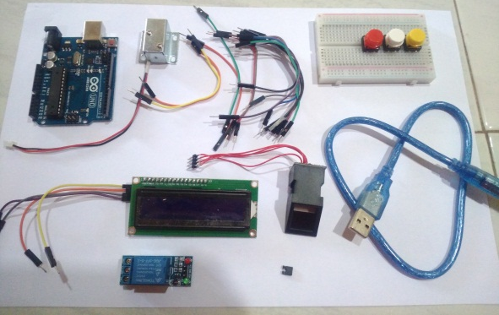
Figure 4.2. System components before assembly
Consists of Arduino Uno, solenoid key, jumper cable , bread board , LCD, fingerprint , Arduino USB, adapter and relay .
- Arduino Uno circuit with Bread Board
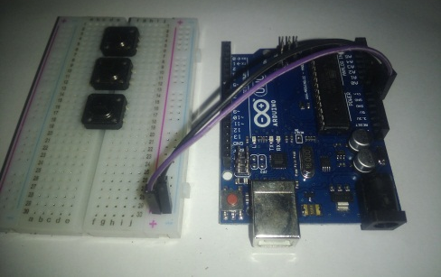
Figure 4.3. Arduino circuit with bread board
Functions to receive a current supply of 5 volts from the Arduino Uno to the bread board .
- Fingerprint sequence
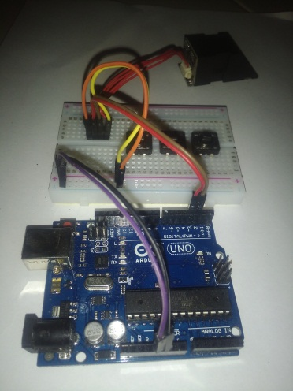
Figure 4.4. Fingerprint and Arduino circuit
Functions to read or detect fingerprints whether they are correct (registered) or wrong (not yet registered).

- Push Button Circuit
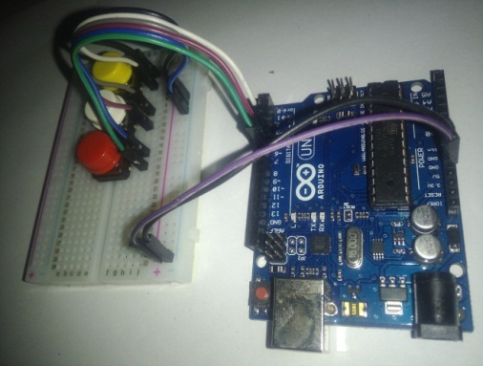
Figure 4.5. Push Button and Arduino circuit
The push button functions to determine the options provided via the LCD screen.
- LCD circuit
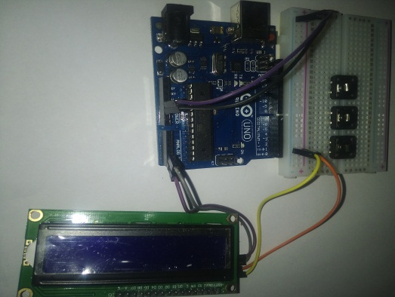
Figure 4.6. LCD and Arduino circuit
Functions to display information in the form of open key reports and display options when registering a new user.
- Solenoid Circuit
Figure 4.7. Solenoid Circuit
Functions as an output in the form of movement of the solenoid lock which is given a current voltage of 12 volts to unlock the cupboard if the fingerprint sensor is successful.

- Application to Objects
Figure 4. 8 . Application of the system to objects
After testing, the system can be applied/applied to cupboard objects.
- Testing and Analysis
- First Test
The first test of the system was tested using the author's fingerprint, using the right thumb print, before the testing process the right thumb was first registered on the fingerprint sensor . Figure 4.9 below is a picture of the thumb for carrying out the first test.
The test step is to place your finger on the fingerprint sensor area , noting that the door is closed. So if the sensor succeeds in identifying and reading the fingerprint, the system will turn on the relay once and the solenoid will activate so that the door can be opened, as well as measuring the time required by the system to read the fingerprint.
The first test using the right thumbprint (thumb) showed that the system could work well with the reading time interval from placing the finger on the sensor area until the door opened was 2 seconds. Or it could be said that in this first test it was found that the system took 2 seconds to recognize the right thumb print until the door opened.
- Second Test
The second test is almost the same as the first test, both in terms of procedure and everything else, only in the second test the test object is replaced with the author's left thumb. To see more clearly, see Figure 4.11 below.
So from the second test it was found that the system could recognize and read the left thumbprint with a reading time interval until the door opened of 2 seconds, or the same as the first test data.
- Third Test
To speed up the testing process, in this third test the author took 2 tests in carrying out the test, namely with the test object of the index finger of the right hand and the left hand. From this test, data was obtained that the two times required by the system to read until the door opens (solenoid/relay on) is 2 seconds, both on the right finger and 2 seconds on the left finger. For more clarity, pay attention to table 4.1 below.
Table 4.1 Third Test Data.
No | Finger | Status | Reading Time
1 | Right index finger | Read | 3 seconds
2 | Left index finger | Read | 2 seconds
- Fourth Test
The fourth test used the object of the middle finger of the author's right hand and left hand, so the following test results were obtained in table 4.2.
Table 4.2 Fourth Test Data
No | Finger | Status | Reading Time
1 | Center right | Read | 2 seconds
2 | Center left | Read | 2 seconds
- Fifth Test
The fifth test is not much different from the previous test where the test object uses the ring finger on the author's right and left hand. The ring finger test aims to find out how far the system can recognize the five fingers so that it is hoped that the author can draw conclusions from the system later, as for the test result data The five can be seen in table 4.3 below.
Table 4.3 Fifth Test Data
No | Finger | Status | Reading Time
1 | Sweet right | Read | 2 seconds
2 | Sweet left | Read | 2 seconds
- Sixth Test
The sixth test used the object of the little finger of the author's right and left hand, with the same system test procedure as the previous one, so that the following table 4.4 was obtained.
Table 4.4 Sixth Test Data
No | Finger | Status | Reading Time
1 | Right pinky | Read | 2 seconds
2 | Left pinky | Read | 1 second
- Seventh Test
The seventh test uses an object that is different both in terms of the physical size of the finger and the age of the finger. This seventh test uses the finger of a 17 year old student weighing 48 kg, female. The test with the student object aims to find out the system parameters, whether the system can recognize and reading the student's finger or not, which does not rule out the possibility that the condition of the writer's and student's fingerprints is different.
Table 4.5 Seventh Test Data
No | Finger | Status | Reading Time
1 | Right thumb | Read | 2 seconds
2 | Left thumb | Read | 2 seconds
3 | Right index finger | Read | 2 seconds
4 | Left index finger | Read | 2 seconds
5 | Center right | Read | 2 seconds
6 | Center left | Read | 2 seconds
7 | Sweet right | Read | 2 seconds
8 | Sweet left | Read | 2 seconds
9 | Right pinky | Read | 2 seconds
10 | Left pinky | Read | 2 seconds
- Eighth Test
The eighth test uses fingerprints in different conditions, namely wet, dusty and dry. This test aims to determine whether conditions like this affect access to the cupboard or only affect the access time to the fingerprint .
Table 4.6 Eighth Test Data
No | Finger Condition | Status | Reading Time
1 | Clean and Dry | Read | 2 seconds
2 | Dusty | Can not be read | -
3 | Wet | Can not be read | -
- System Test Results
After carrying out several tests as above, the author got some data, including that the system can identify or recognize fingerprints, that the fingerprints a person has vary in thickness and width, thus affecting the time to access the fingerprint.
The condition of the fingerprint certainly affects fingerprint access. The results obtained by the author after testing showed that the fingerprint only accepts fingerprints in clean and dry conditions, while dirty and wet conditions are unacceptable or unreadable.
- CONCLUSIONS AND RECOMMENDATIONS
  - Conclusion
As a result of implementing an automatic lock system on cupboards using a microcontroller-based fingerprint, the author can conclude as follows:
            - After designing the system and testing, it can be seen that the fingerprint scanner can be applied to cupboards as a security system.
            - System security fingerprint finger capable read fingerprint finger man more from one , then from That system capable register more from one user/ users . So that user cupboards that use system This capable accessed more from one person.
  - Limitations of Research Results
The implementation of this system certainly does not rule out the possibility of deficiencies in the system. The following are the disadvantages of this system, namely:
                - This system depends on the electricity supply when used, System This can used with Genre available electricity , if​ No There is intake electricity so system This No can used .
                - fingerprint system cannot read dirty (dusty) and wet fingerprints.
  - Suggestion
In the research carried out by the author, suggestions for an automatic lock system were taken as follows:
            - Create portable device storage so that it can be used in several other cupboards.
            - supply (UPS) is needed so that it can still be used in the event of a power outage.

BIBLIOGRAPHY
Albet, M., Ginta, PW, & Sudarsono, A. (2014). Automatic Window Creation Using Light Sensors. Infotama Media Journal , Vol. 10 No. 1.
Annisya, Hermanto, L., & Candra, R. (2017). Security System for Opening and Closing Safe Locks Using Fingerprint Based. Journal of Informatics and Computers , Volume 22 No. 1.
Barakbah. (2013). Logic and Algorithms. Surabaya: Surabaya State Electronics Polytechnic.
Dharmawan, HA (2017). Microcontroller. Malang: UB Press.
Dinata, YM (2016). Arduino Is Smart. Jakarta: PT. Elex Meidia Komputindo.
Firmansyah, Y., & Udi. (2018). Application of the SDLC Waterfall Method in Creating a Web-Based Academic Information System. Case Study of the Al-Habi Sholeh Islamic Boarding School, Kubu Raya Regency, West Kalimantan. Information Technology & Management , Vol. 4 No.1.
Hasyim, N., Hidayah, NA, & Latisuro, SW (2014). Design and Development of a Web-Based Cooperative Information System at the New Citizens Cooperative Mts N 17 Jakarta. Journal of Information Systems , 1-10.
Hoffman, J. (2018). Mastering Arduino. Birmingham: Packt Publishing, Ltd.
Mazidi, M. A., Naimi, S., & Sepehr, N. (2017). THE AVR MICROCONTROLLER AND EMBEDDED SYSTEMS. New York: Pearson Education, Inc.
Merucahyo, PY, Sadewo, AB, Karuru, C., Martanto, & Priantoro, AT (2016). Wireless Based Automatic Control of Fish Pond Water Quality. Widya Teknik Scientific Journal , Volume 15 Number 2.
Oroh, J.R. (2014). Design and Build a Motorcycle Security System Using Fingerprint Recognition. Electrical and Computer Engineering , 1-7.
Pilat, C.F. (2016). Evaluation of the implementation of the internal control system for cash receipts at the contractor company PT. Indonesian Blessing Granary. EMBA Journal Vol 4 No. 2 , pp. 681 - 691.
Prasetyo R., A., Isnanto, RR, & Widianto, ED (2014). Automatic Unlocking System Using Knock Pattern Identification. Journal of Computer Technology and Systems , Vol. 2.
Sukarma, IN, Widarma, IG, & Wiguna, AS (2016). Design and Build a Safe Security System Using a Combination of Passwords and Fingerprints Based on the Atmega328 Microcontroller. Matrix Journal , VOL. 6, NO. 2.
Susanto, H. (2015). Practical Arduino Guide for beginners. Trenggalek: eagle magic.
Tobing, SL (2016). Door Safety Design Using Fingerprints and an Android Smartphone Based on an Atmega8 Microcontroller. Electro , 10-15.
Turang, DA (2015). Development of a Mobile-Based Light Control and Saving Relay System. Informatics .
Tyoso, J. S. (2016). Management information System. Yogyakarta: Deepublish.
Zulfriandi. (2014). Dental Polyclinic Application Design (Case Study: Indonesian Attorney General's Dental Polyclinic). Journal Vol. 8.

